Assignment 1
By Jesper Bertelsen, AU-ID:au689481

Indholdsfortegnelse
Assignment 1 1
Declaration 1
Problem 2
Plan: 2
Load: 2
Up down: 2
Enable and reset: 4
The design 6
Declaration: 6
The inverter: 6
The transmission gate: 7
NAND gate. 8
The D-Flipflop 9
Comments before the 5-bit counter. 10
The multiplexer 11
The 5-bit counter 12
Error found 13
Result 13
Revisiting the DFlipflop. 14
Error found. 17
Enable & load 21
Error found 24
Final conclusions 25

Declaration
My report got a bit huge, as I stumbled upon some difficulties, that I had to troubleshoot to get it to work and did it by trial and error. I conclude it all at the end, in my final conclusions.

Problem
A counter is needed. It is supposed to be a synchronous up / down counter, meaning it can count up as well as counting down from an initial value. It is supposed to have asynchrounous resets as well, meaning it resets instantly, when reset is logic HIGH.
Then I am supposed to test my design in LTSPICE for:
- Its reset signal,
- Its load signal,
- Its enable signal,
- Its up/down functionality.
For my LTSPICE document, I am supposed to make my own subcircuits and use them.
I am then supposed to document my work, with documentation about the design but also about the testing strategy.
My report should contain a description of:
- The designs of all the subcircuits and blocks.
- The general operation of my design.
- How I test and verify each feature.
- The challenges with my design
- Sources that I have used? (“Describe the author’s contributions to the assignment”)

Plan:
The counter differs on other counters that I have designed, with needing the ability to count down as well as having a predetermined load.

Load:
The load means that it can start from 0, but it can also have an initial value.
With 5 bits, it could have a value $D={\left(11111\right)}_{2}={31}_{10}$

Up down:
1 bit needed.
Clock up -> Divide by 2 method. Q -> Logic high til en ny flip flop.
$Toggle\left(1\right)→Q_{1}$
$Toggle\left(1\right)→\overline{Q_{1}}→toggle\left(2\right)→Q_{2}$
$Toggle\left(1\right)→Q_{1}$
$Toggle\left(1\right)→\overline{Q_{1}}→toggle\left(2\right)→\overline{Q_{2}}$

For the up counter, we see that they $Q_{x}$ uses $\vec{Q_{x-1}}$ as its clock. For the counting to be accurate, the $\vec{Q_{x-1}}$ must act when on the falling edge, as the counting would otherwise be delayed to each other. I have drawn the $Q_{1}$ to be affected by the clk’s rising edge, but with this one, it doesn’t matter, it could be on the falling edge instead. We don’t care about the clk too much.

Each Q is then a Dflipflop in itself with:
$State 1→State 2$
$Q_{x} = \overline{Q_{x}}$

$State 2→State 3$
$\overline{Q_{x}} = Q_{x}$
And so repeating.

What we see now compared to the up counter is, that counting down means rising edge trickers.
$State 1→State 2$
$Q_{x} =Q_{x-1}\left(as clock\right)·\overline{Q_{x}}$

And so I see, that I can build a bidirectional counter by interpreting, whether I use falling or rising edge.

Enable and reset:
Enable and reset will be handled within the clock signal.

The counter and it’s clock..

‘’’

That is how I see the counter and the clock part being build.
A dflipflop is positive edge trickered.
For this to work with both the up counting and the downcounting, I must then choose between, whether I use $\overline{Q_{x-1}}$ or $Q_{x-1}$, as I have sketched the installed clock I will be using, to make the positive edge for $Q_{x}$.

Let me start by designing the dflipflop.
Each flipflop is supposed to be asynchronous reset, this is kept in mind for the design.
The design I will be using is a design from lecture 3:
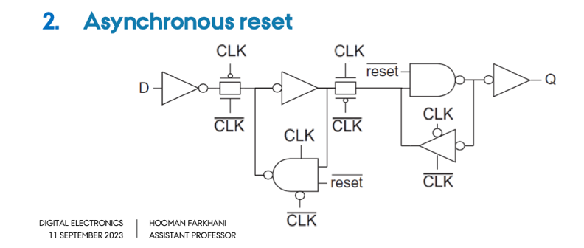
It requires inverters, NANDs and transmissiongates for the clock.
I had said, that I will be having the enable and reset signal in a clock gate. This is however more direct, and will enable the feauture of the system having an asynchronous reset.
For the enabler I will be putting that in the beginning of this block, but I haven’t decided a way yet, this will come later. Let’s get building the subcircuit.

The design

Declaration:
The transistor model I will be using throughout this design will as of standard be:
Pmos 45, length: 60nm, width: 400nm
Nmos 45, length: 60nm, width: 200nm
I might look into different dimensions, to try to make the propagation delay when falling equal to the propagation delay when rising, but maybe I won’t.

The inverter:
The inverter is simple. It’s just the basic cmos implementation, with a signal both going to the pmos and nmos, having logic HIGH, when the signal is 0, and logic LOW, when the signal is 1.

The transmission gate:
The transmission gate makes sure, that the signal comes through, if the gates is closed. If it is open, then no input can go to the output. If the switch signal is logic HIGH, then the gate should be closed, otherwise open.
The pmos and nmos in combination makes sure, that if the input is 0, then the output would be 0, and if the input is 1, then the output will be 1.
This is used as a switch.

Now I have made the Inverter and the transmissiongate. Now is maybe the time to test if these function well, before I move on.
This is my test setup. An input that goes into a transmissiongate, that also takes in a switchsignal into the gates of the nmos and pmos. For the pmos signal it has to be inverted to work as a switch, and that’s how the inverter is being tested.

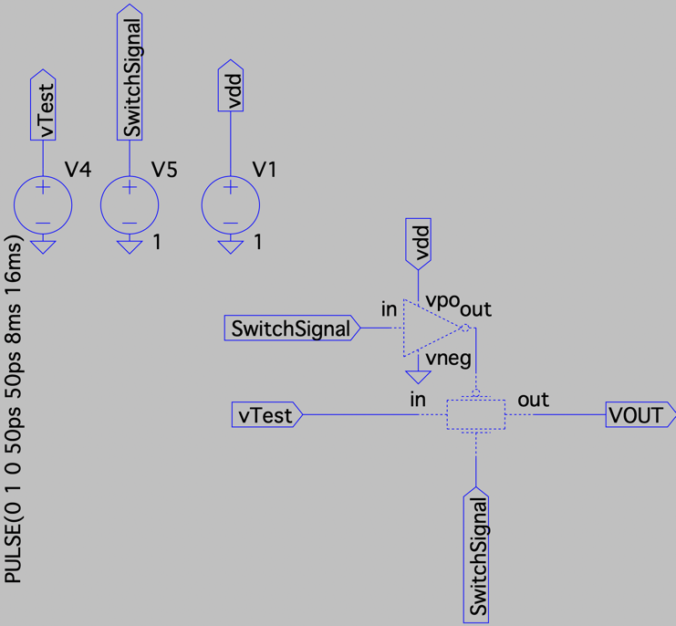

Figure 1: Test schematic for the transmission gate
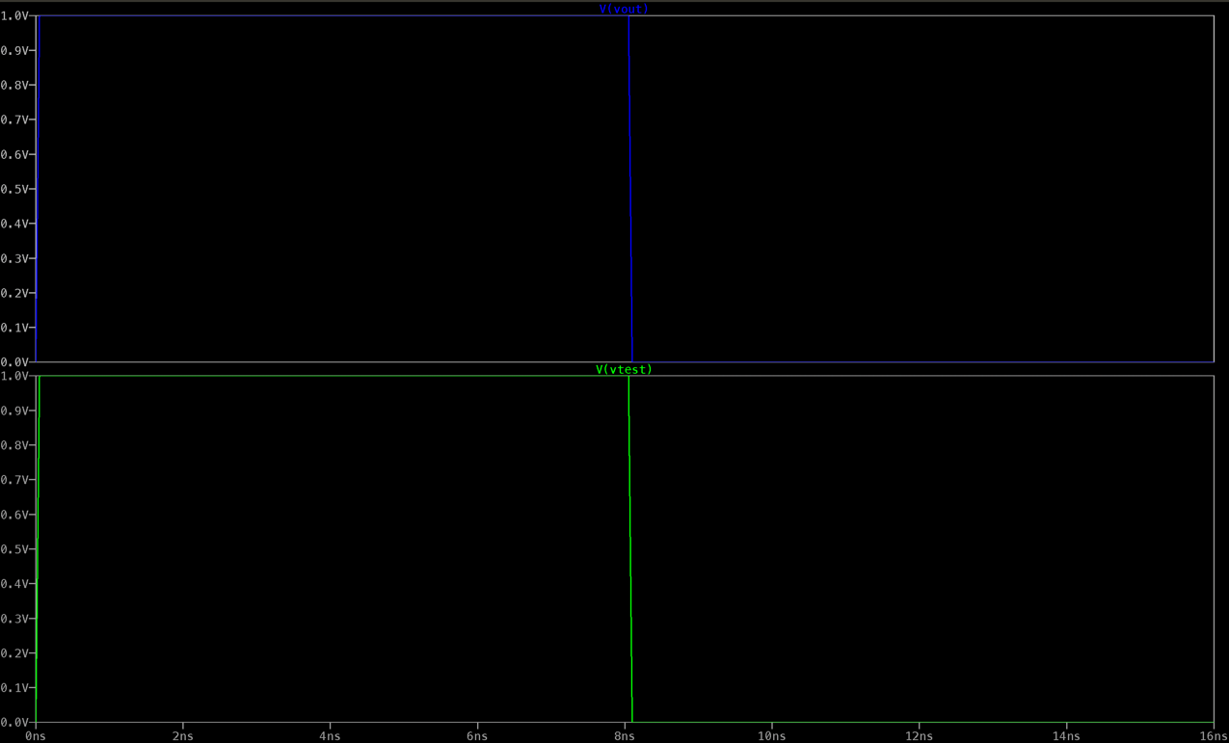
With the switch signal being 1V we expect the gate to be closed. With the input signal going from 1V to 0V, we then expect that the output will go from 1V to 0V. This is the case of the test run, so these gates should be working.

Figure 2: Test run of the transmission gate

NAND gate.
Next up is the last component, the NAND gate.
We have used the NAND gate in our lectures a couple of times.

$$Y=\left(\overline{AB}\right)=\left(\overline{A}+\overline{B}\right)$$
For the NMOS:
$\overline{Y}=AB$, so we put 2 nmos transistors in series, gated by A&B.

For the PMOS:
$Y=\left(\overline{A}+\overline{B}\right)$
Taken the conjugated of these equals to sending in, A & B into the pmos transistors in parallel.

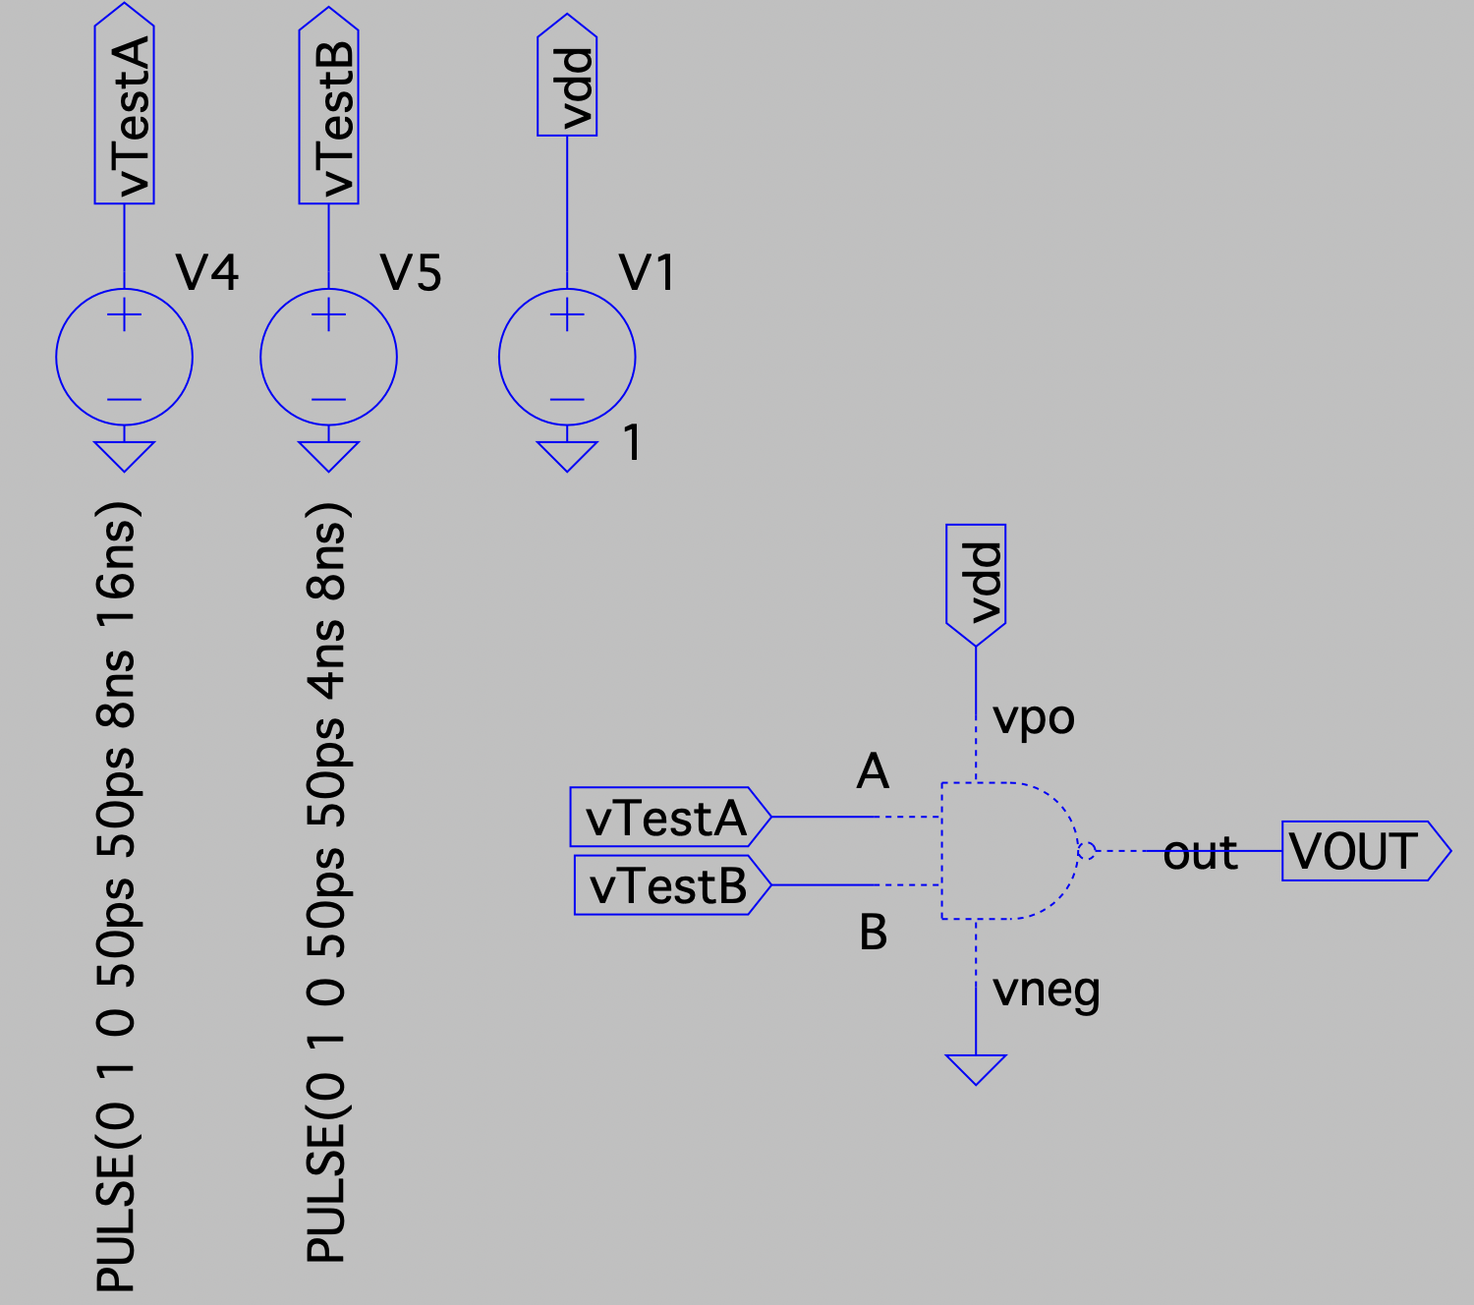
Now after creating the subcircuit in LTSPICE, let’s get to testing it.
Figure 3: My test schematic for the NAND gate

In my test schematic I have put up to bits pulsing, equaling a count down, 11 -> 10 -> 01 -> 00.
For the NAND gate we then expect it to be zero when 11, and then 1 for the other inputs.

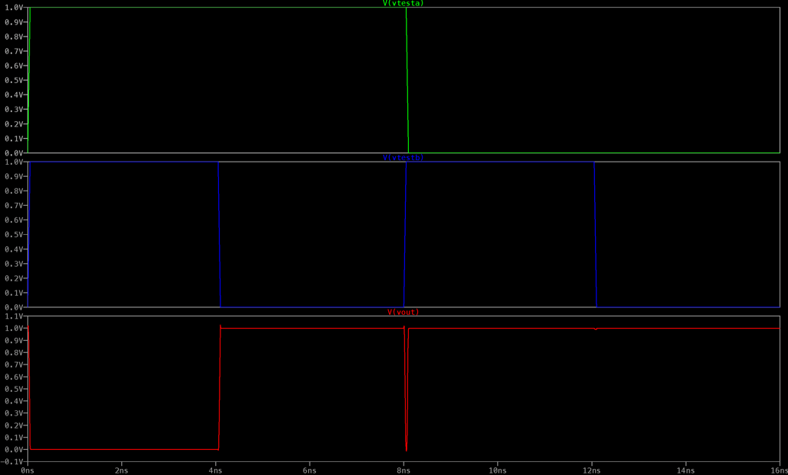
Figure 4: Test run of the NAND gate

Looking at the results I can see, that the results verify the theory. There is a little spike when going from 10 to 01, but this is due to the rise and fall of the two bits, and is nothing concerning.

The NAND then works properly.

The D-Flipflop
Now that every component withing the dflipflop is created and tested, let’s now build the D flip flop. The design was as previously mentioned, shown in one of our lectures.

And this is how it looks in LTSPICE.
Figure 5: Schematic of the DFlipFlop
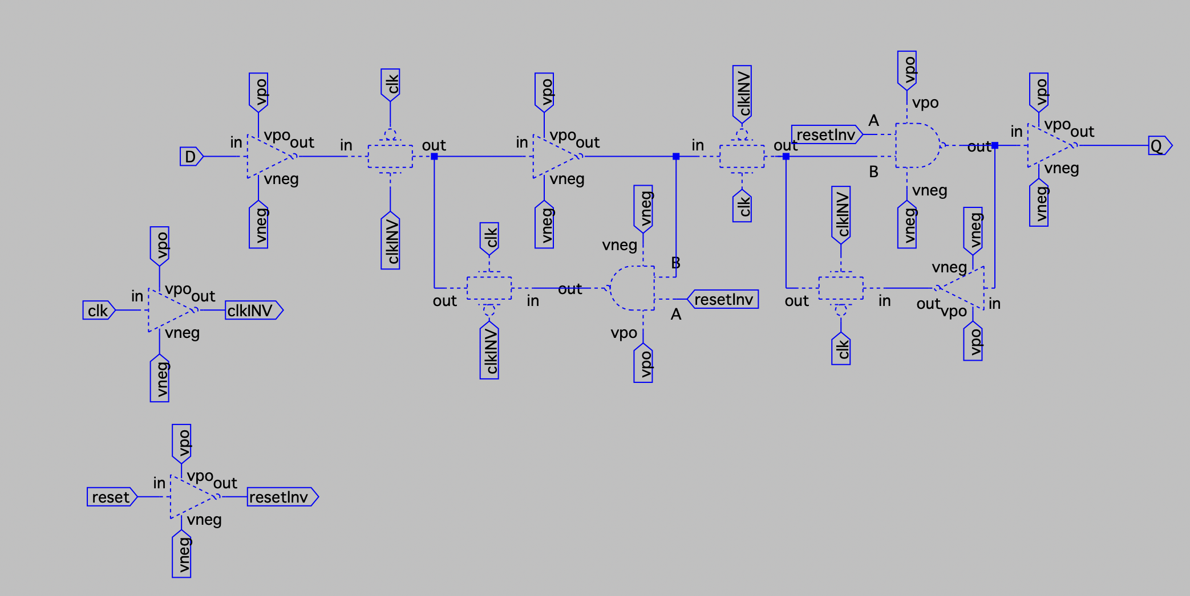

Comments before the 5-bit counter.
As I commented on previously, I need to have a way to determine whether we won’t the falling edge or rising edge to be the clock for the more significant bit. I pointed out, that I might just be able to put in a multiplexer, switching between the default or inverted output. Let’s give that a try.

The multiplexer

Multiplexer design
S | D0 | D1 | Y
0 | 0 | X | 0
0 | 1 | X | 1
1 | X | 0 | 0
1 | X | 1 | 1
‘’’

$Y=\overline{S}D_{0}+SD_{1}$
The design I use comes from a previously shown design from our lectures.
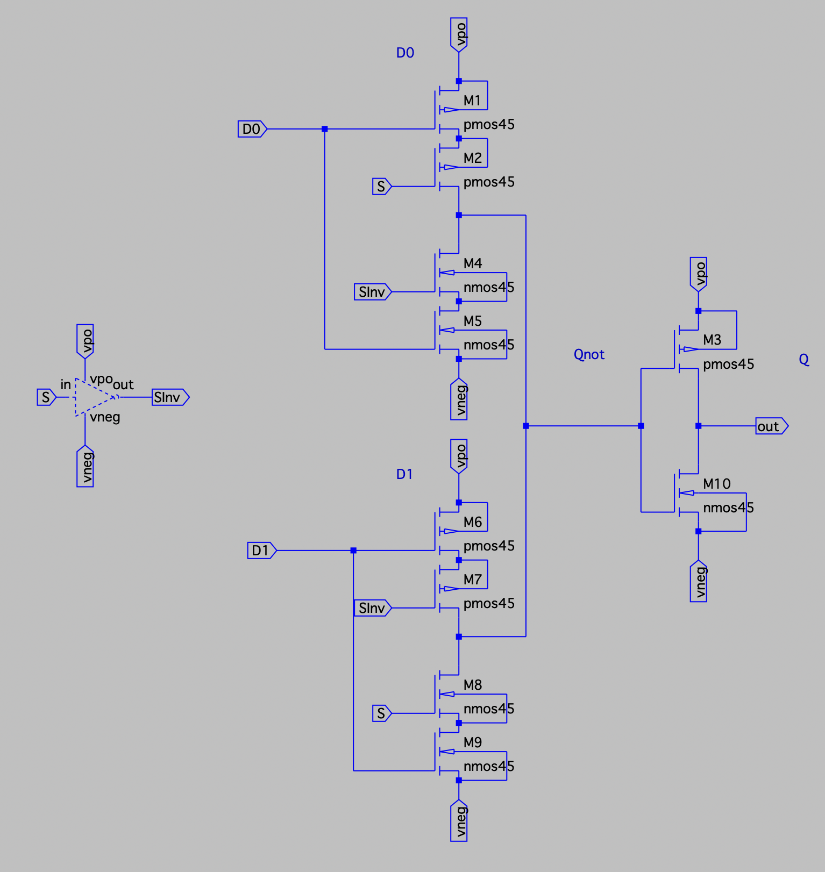
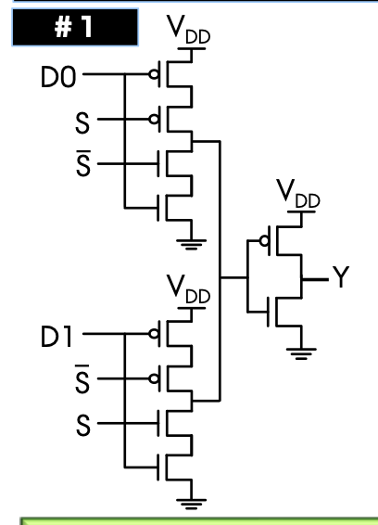
Then making it to the following subcircuit:
Figure 6: Multiplexer designed in ltspice
Figure 7: Multiplexer design from class

Equaling the following analysis: 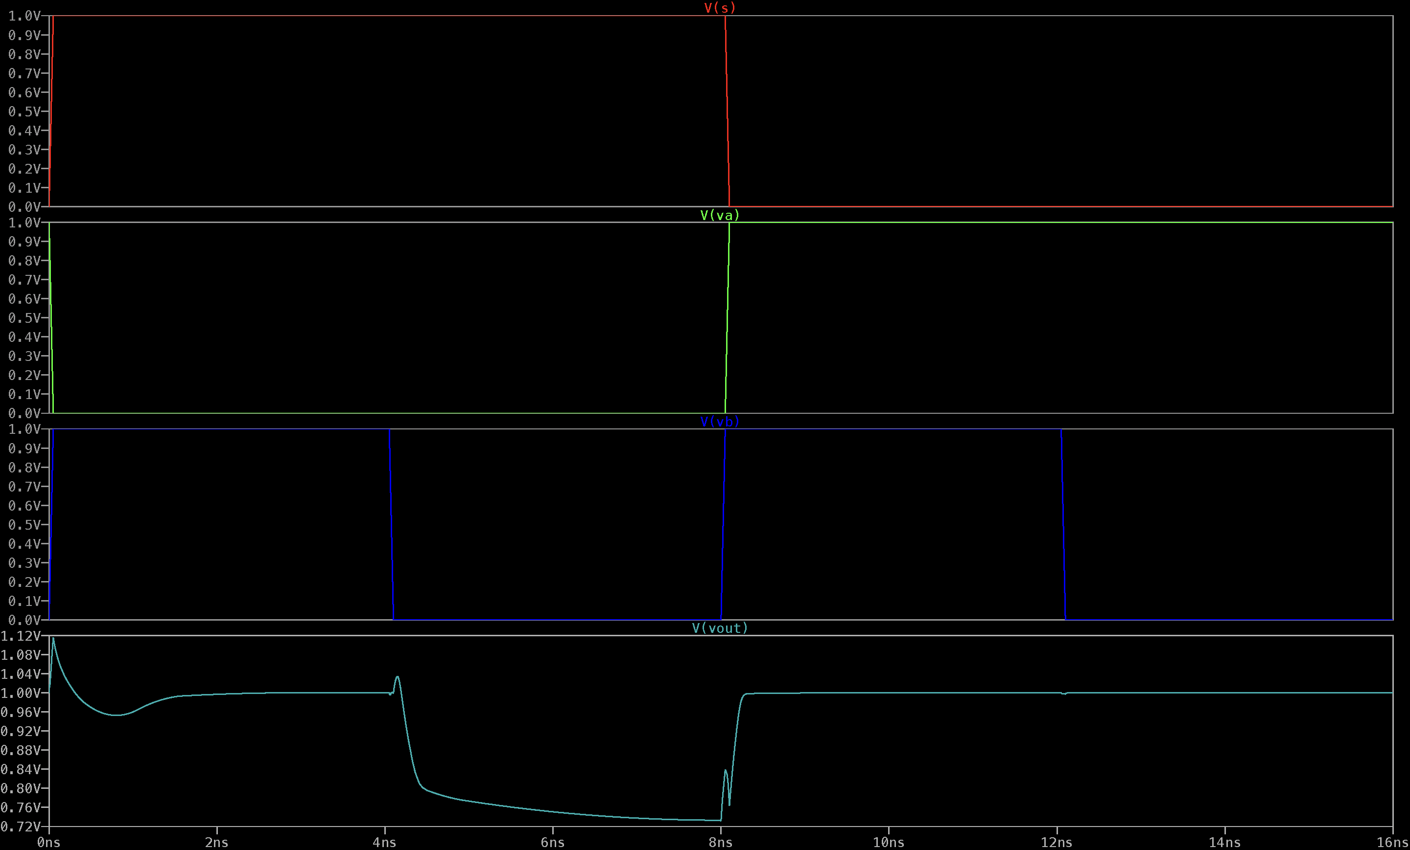
Which shows it isn’t ideal, but works as a multiplexer, with S being 1 at start, choosing the vb voltage, and then S switches to 0, choosing the voltage of va.

The 5-bit counter
I should have everything prepared for making the 5-bit counter. Let me make the counter.
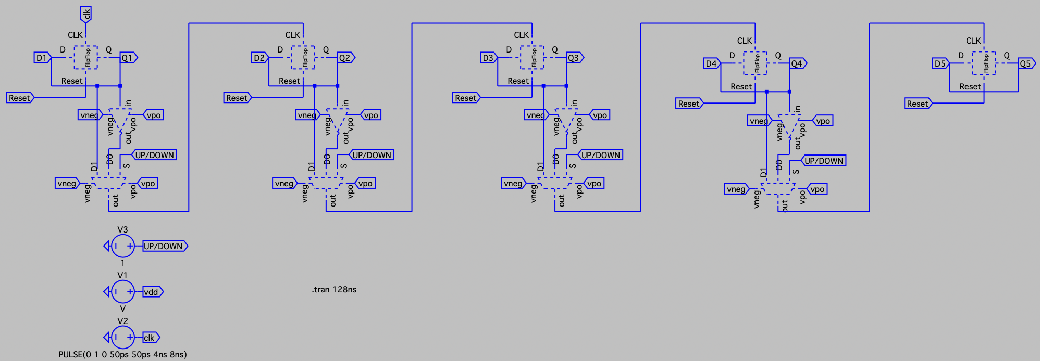
The 5 DFlipFlops. The first Dflipflop having a pulse generator as its clock, the next 4 bits $clk_{x}=Q_{x-1} or \overline{Q_{x-1}}$ depended on whether it should have a positive edge tricker or negative edge tricker.
After running it I get:
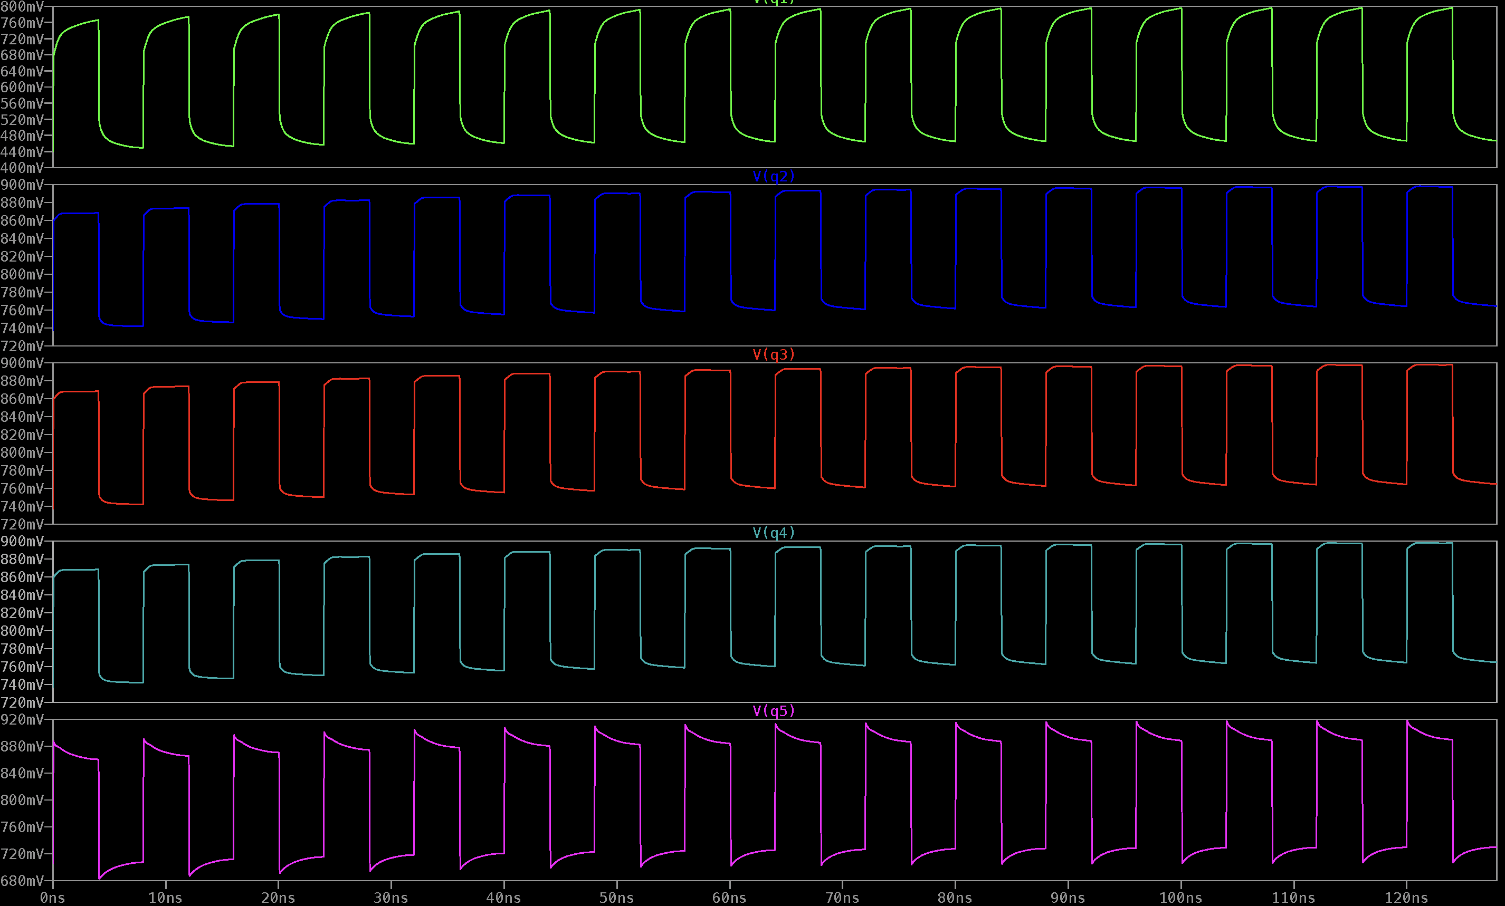
Which isn’t what we wanted.

Error found
And obvious error when looking at the DFlipFlop is, that I had forgotten to supply the flip flop with a vneg terminal and a vpos terminal.
Let’s start by fixing that.

Result
The improved schematic:
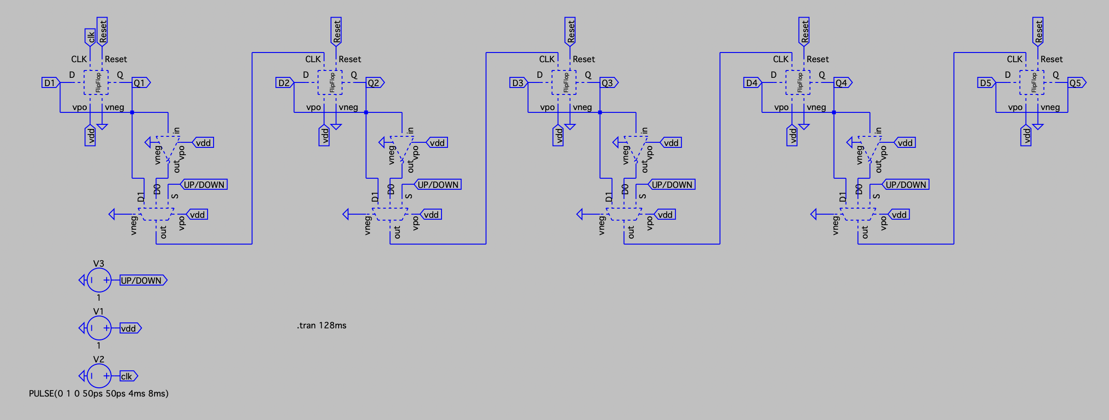

Resulting in:
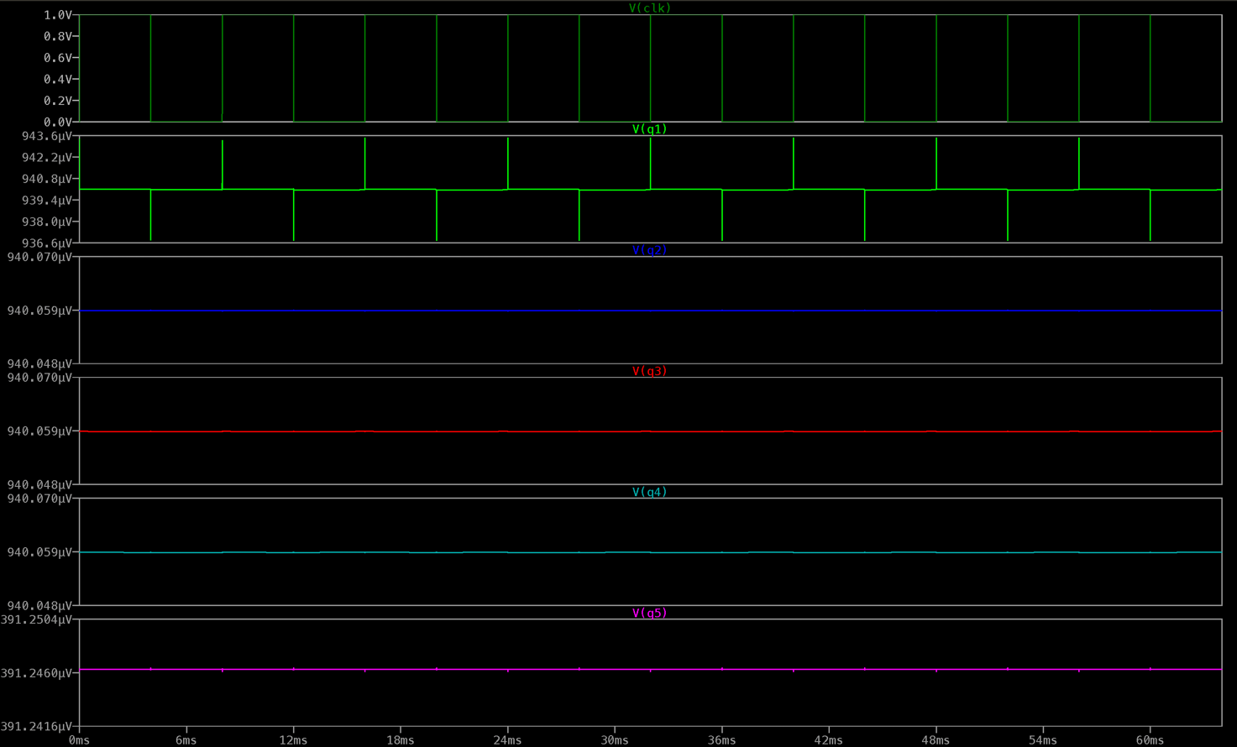
Figure 8: Result after running the 5 bit counter
Which still doesn’t make a lot of sense. The gates are now powered. When I think about it, I think that I forgot to test the DFlipFlop. Seems as the q1 tries to switch its value when clk is rising. Surprisingly, it seems to do so too, when it’s falling. By our knowledge on flip flops, one says that the dflipflop is positive edge trickered, so it to be changing on the falling edge doesn’t make a lot of sense. This might solve itself when I dive into why the dflipflops aren’t working. So I will now do that.

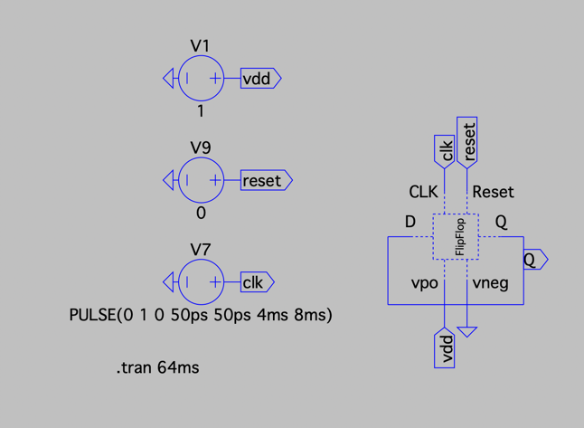
Revisiting the DFlipflop.
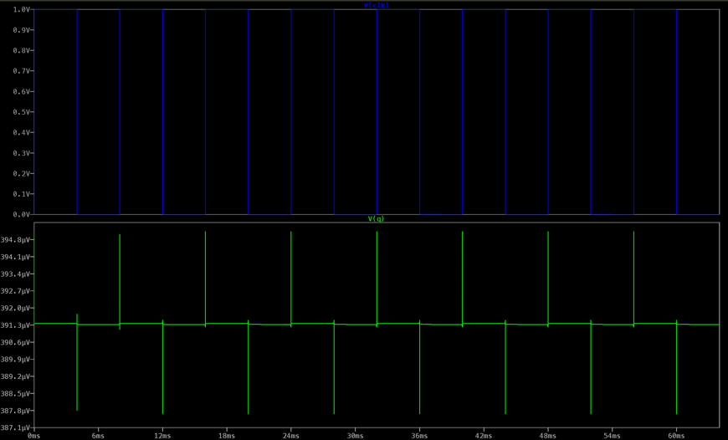
The result seems similar for reset being 0 & 1.
Figure 9: DFlipFlop test schematic

Figure 10: Result of the DFlipFlop testing
What to check.
Is the period to fast? ( Speed doesn’t seem to be the issue, the same occurs when in seconds ).
Are there something wrong with the transmissiongate?

Let me compare the flip flop with the design I got.
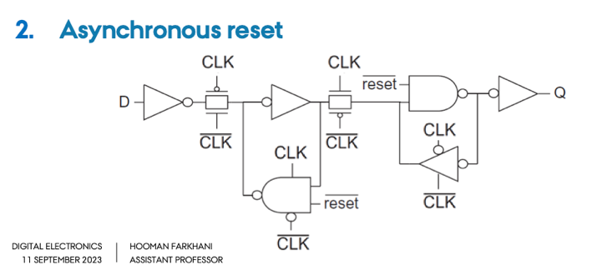

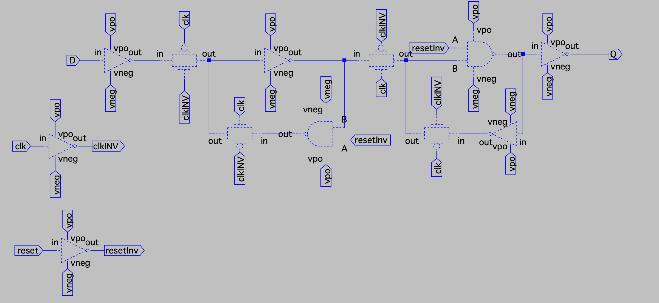

- Block
The data comes in and gets inverted √.

- Block
The input goes into a transmission gate with the Nmos having the inverted signal and pmos the default signal.
This means that when the clk is HIGH, the gate is open. When clk is LOW, the gate will be open.
So the gate will close when on the falling edge.
- Block
An inverter, this one is simple too, and should work.

- Block
The NAND transmission gate in one symbol. This should be the same as my NAND in series with the transmissiongate. The NAND receives the input and a reset inverted signal. The tranmission gate gets clk inverted into its pmos channel, and clk through its NMOS channel. This gate will be closed when clk is logic HIGH and open when clk is logic LOW.

- Block
The transmissiongate gets clk inverted into its pmos channel, and clk through its nmos channel. This will be open and closed at the same times as the transmissiongate in block 4.

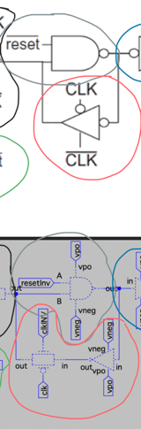
- Block
The NAND gate receives the input and an inverted reset signal. This should work just fine.

- Block
An inverter receives the input and sends it into the transmissiongate. This is simple and should work.
For the transmissiongate, it has clk into its pmos channel, and clk inverted into its nmos channel, as it is at the inverted transmissiongate symbol too.
This gate should be open when clk is logic HIGH and closed when clk is logic LOW.

- Block
An inverter inverts the signal, this should be straight forward and should work.

Lets test its functionality to different clock values.
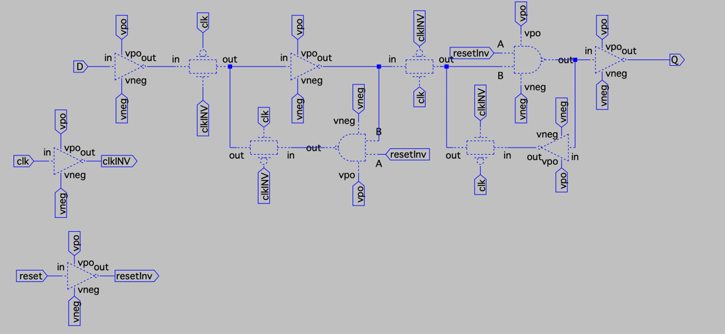
$clk=HIGH$
Equivalent circuit

$clk=LOW$

The design is from a lecture, so I would think, that the design should work.

Error found.
So by standard we say that the signal from the DFlipFlop will become its own inverted when toggled by a clock. By default we would then get $\overline{Q}$. This design has an inverter at the end, given the $Q$ instead. So when cascading more flip flops in series I didn’t get the result I expected. But when testing the flipflop with the node $\overline{Q}$ I got:
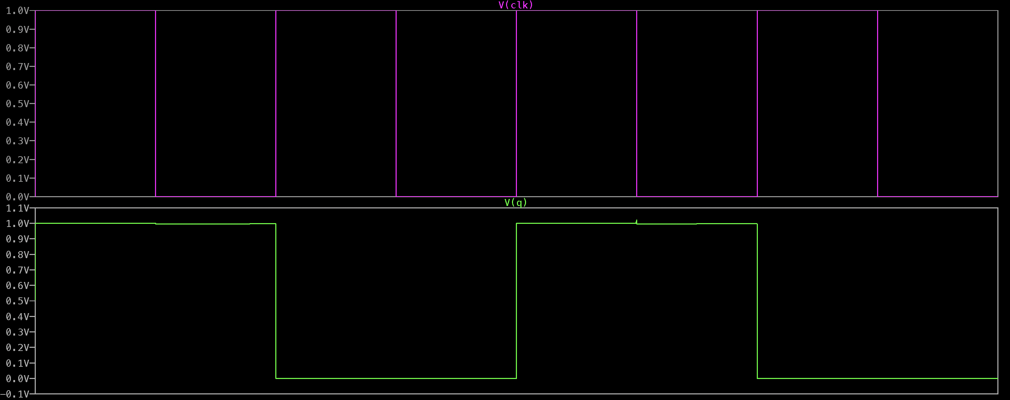
From this schematic:

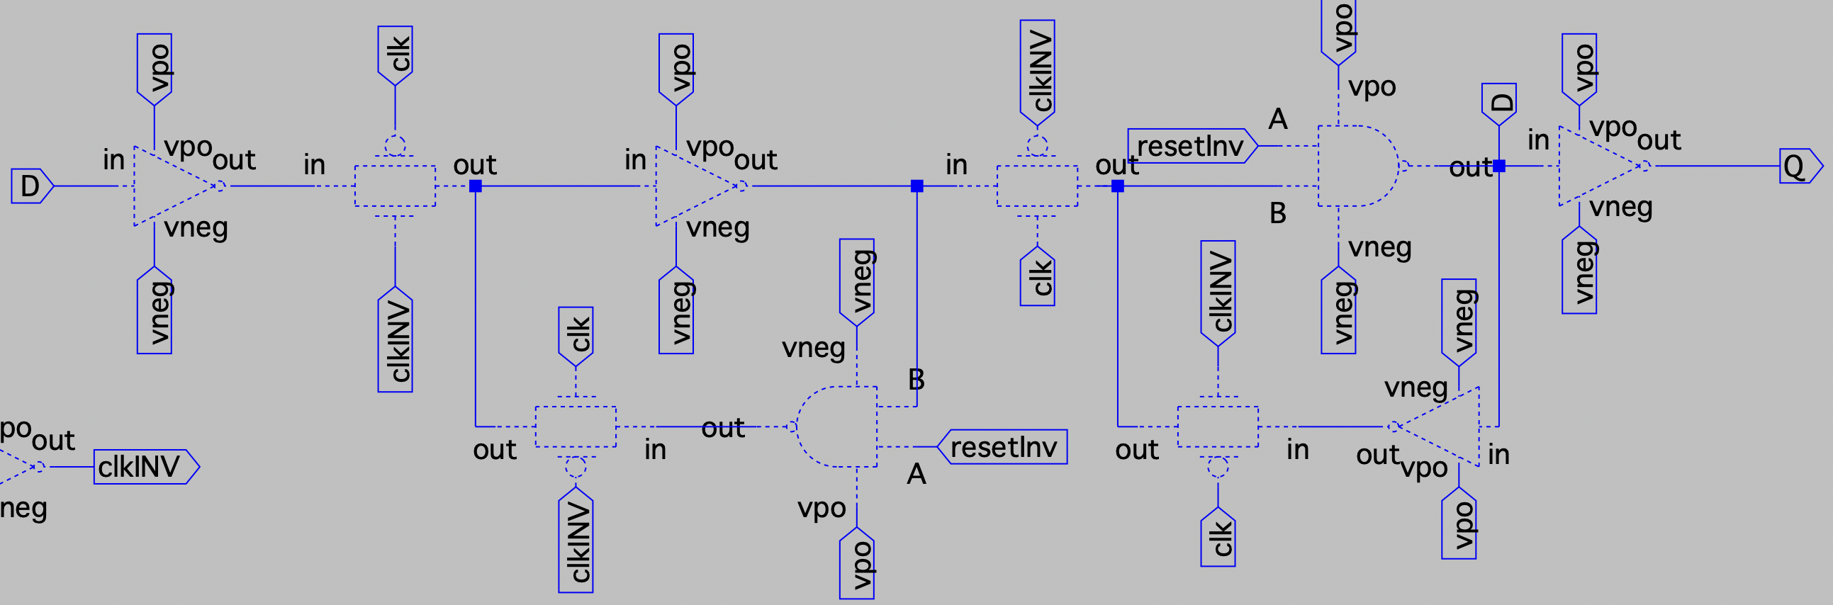
Now corresponding to the sketch:
Instead of $Q$ going to $D$

I cut the last part out, leaving me with only $\overline{Q}$.
As of before, my block looked like this:

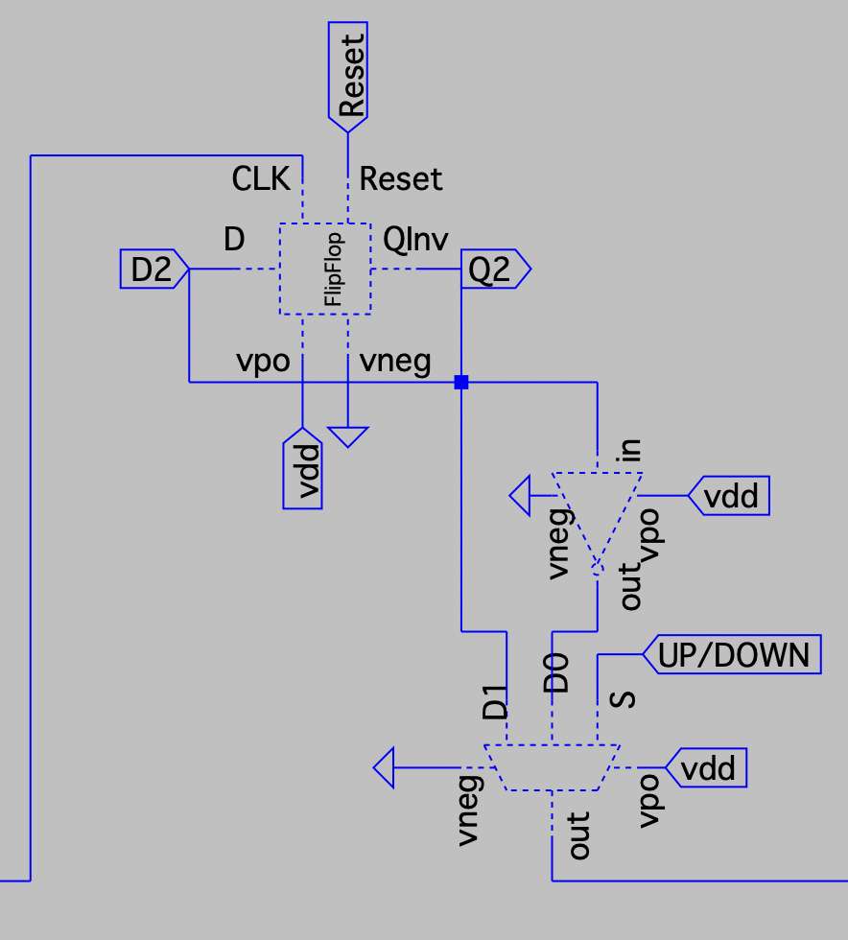
Where I inverted the signal to get $\overline{Q}$ if you wanted to count down.
Now that I have changed the values, S being 0 means counting down, and S being 1 means counting up. Counting up should be default, so I am gonna change this up.

Now my design looks like this:
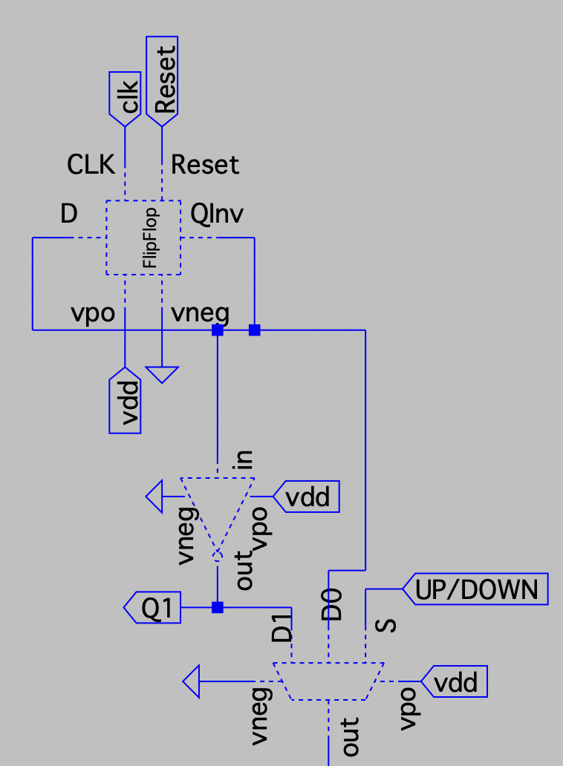

Repeating this block for my 5 bits makes the schematic look like:
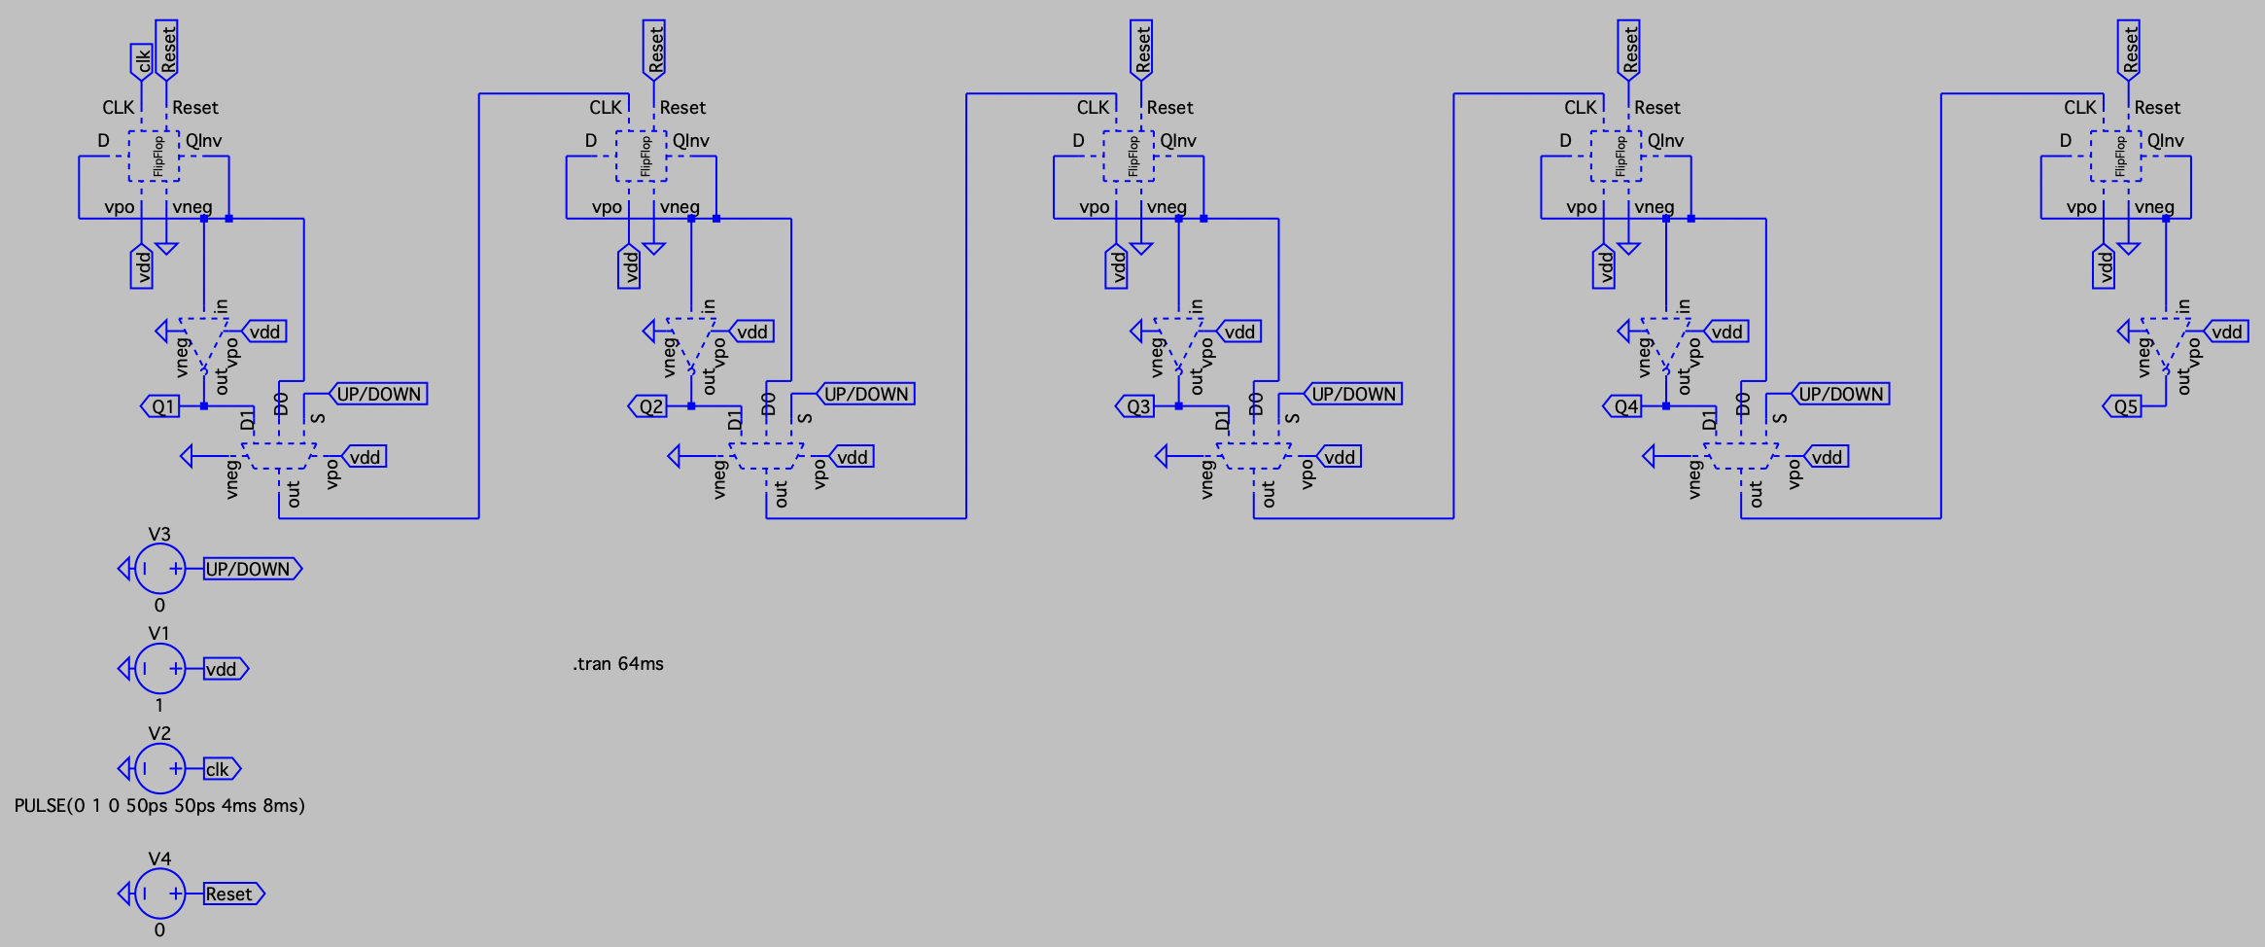

Repeating for 64ms with the clock having a period of 8ms we expect to get: $\frac{64}{8}=8$
A count up to 8. The test results:
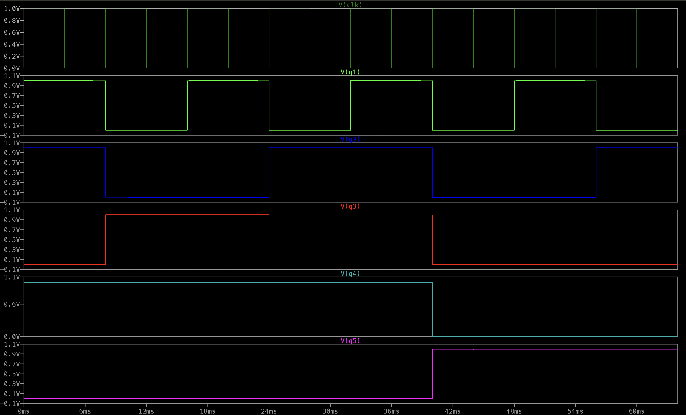
The test results are strange.
The sequence is: ${\left(01011→01100→01101→01110→01111→10000→10001→10010\right)}_{2}$
We see that we do indeed have a count up, but from ${\left(11→18\right)}_{10}$

Let me see the initial values:
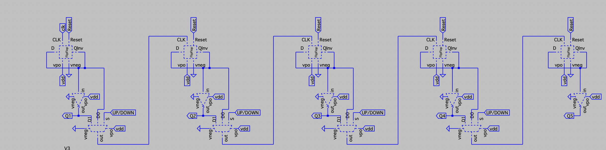
There initial values should all be 0.
I could hard reset them all before starting the clk. This might insure me, that they will start at 0. Let me do that.

New schematic:
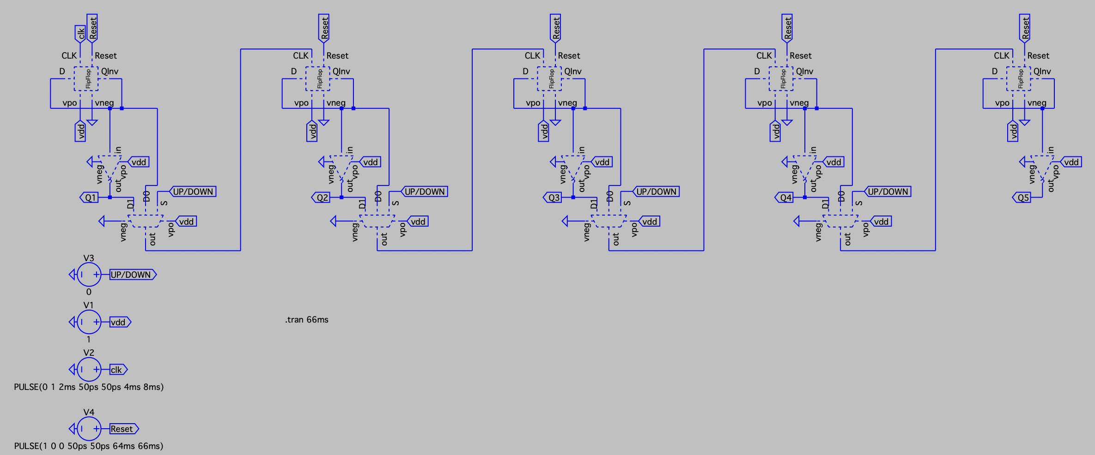
Which give the result:
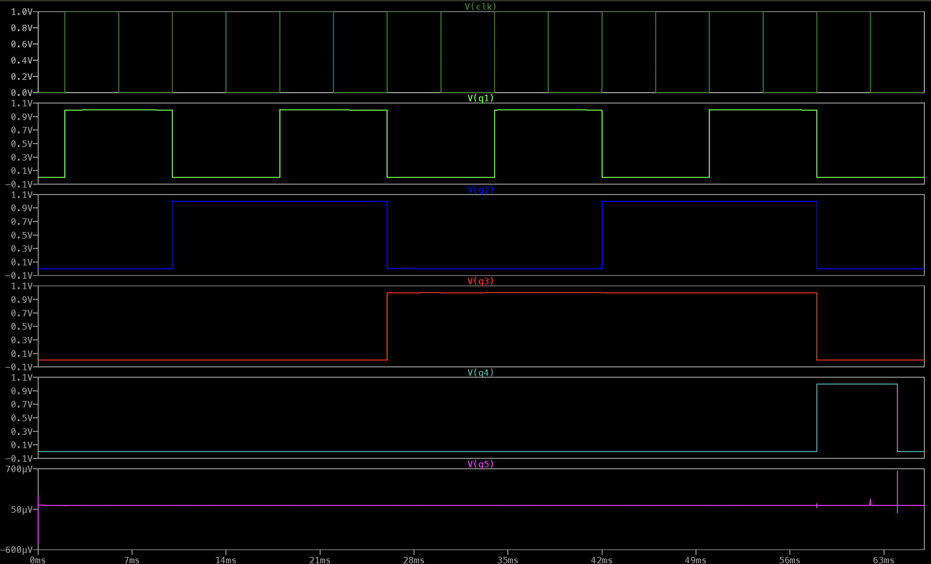

First segment:
${\left(00→11\right)}_{2}$

Second segment:
${\left(100→111\right)}_{2}$
And then some strange behavior, but this might just be my pulse.

Hard resetting it at the beginning then ensured me, that I started from 0.
Let me count to 31 now.
Having a period of 8ms, this means, that I should let it run for
$$8ms·32=256ms$$
$$2ms delay+256ms=258ms runtime$$

The result has shown to be accurate. My test results can be found in my final conclusions.

Enable & load
And now to a part that I have neglected this whole time, as I wanted to get the other parts to work before I did so.
I have thought this to be straight forward. Right now, the only value that I can change my bits to, is 0, meaning a hard reset.
Making the enable & load feature means I could instead choose the load values to be 0, not requiring me to do it the reset way, while still having the flexibility to start from any value that I want.
My thoughts upon what it takes:

So when the enabler is 0, the preset value will be the load data bit. When the enabler is 1, the dflipflop will act as it did before this feature, but now has a preset value. Let me add this to my blocks.

My new schematic looks like this.
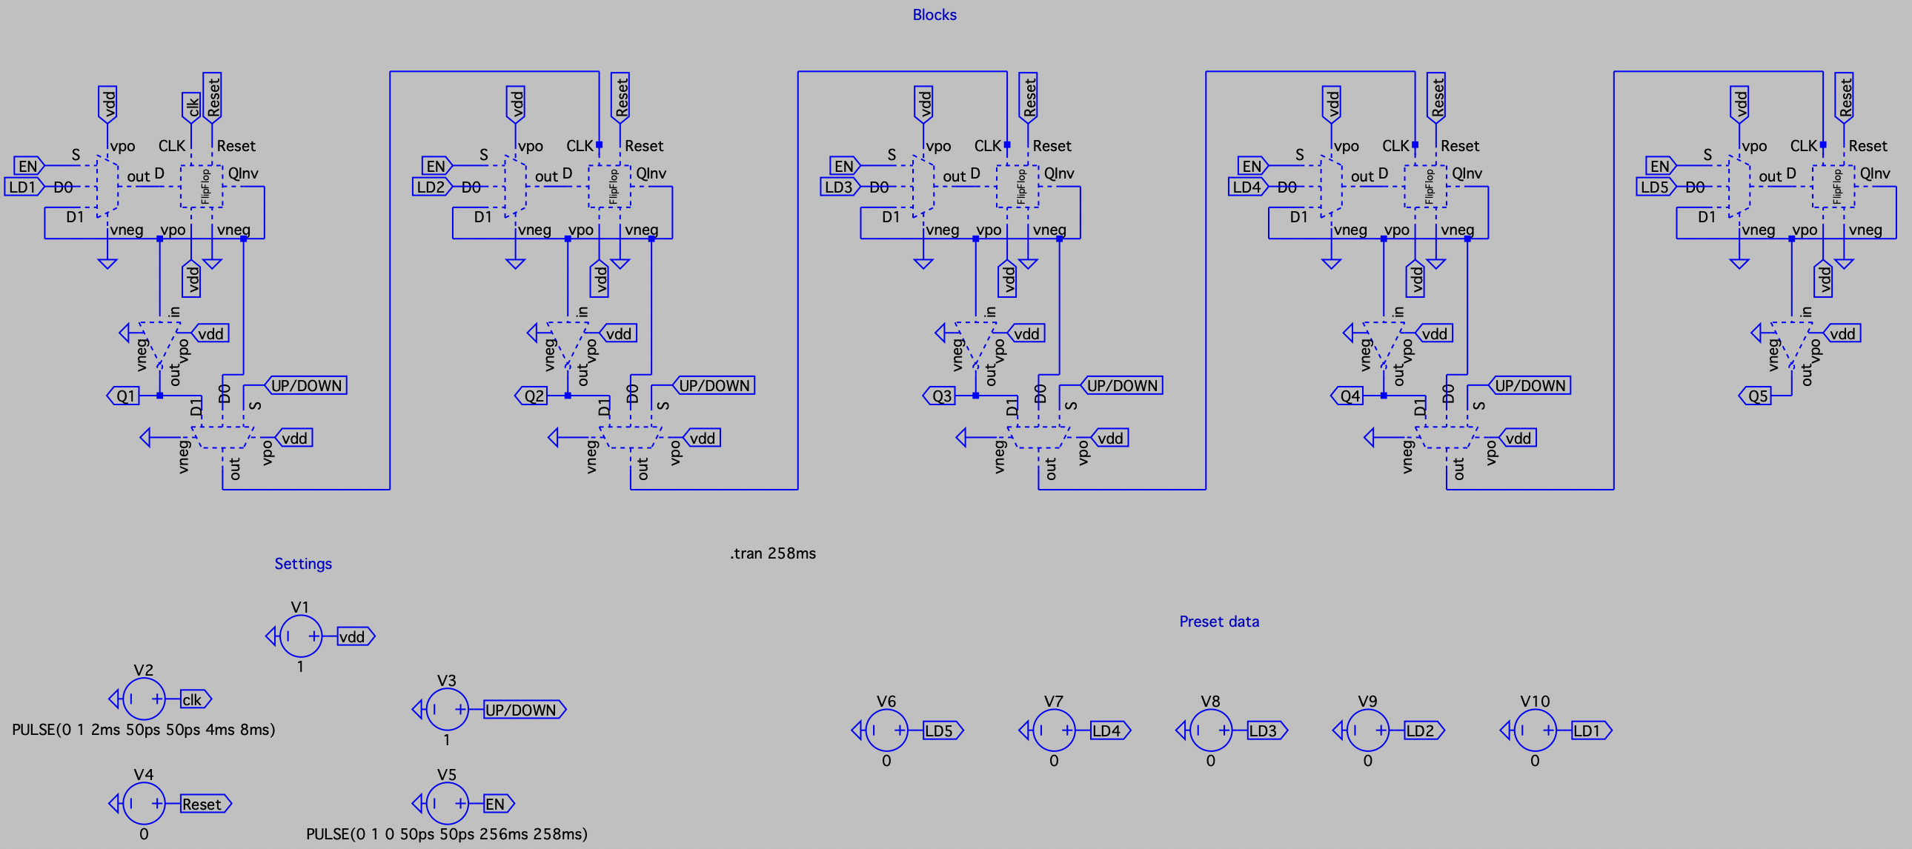
Having changed the hard reset with an enabler being 0 for the first 2ms, sending the load into the flip flop and then being on for the next 256ms.
For the count down from 31 this works with this setup, being 0 at the beginning and then going to 31 and downwards.
For the count up this didn’t work. Changing the enabler to starting at 1V and then being on for 0V for 2ms with a period of 258ms, it worked again. This still worked for the count down.
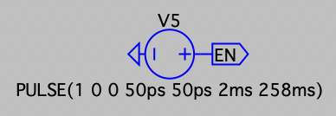

Now was time to set a preset value and check if that worked.
My schematic:
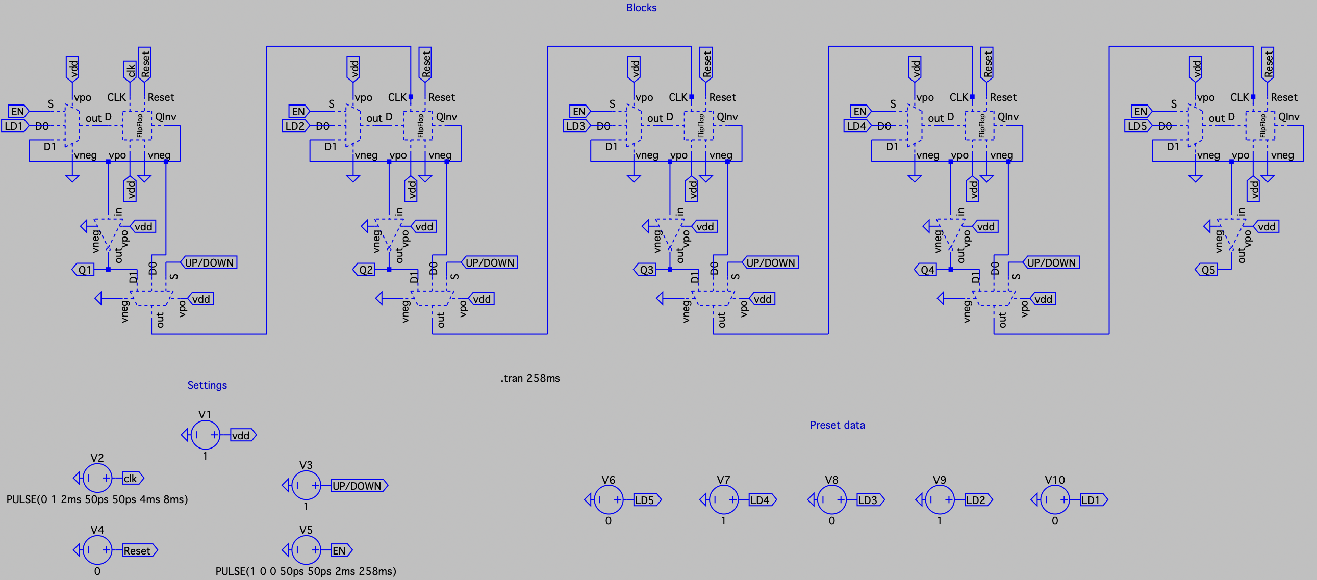
The preset value I choose was ${\left(01010\right)}_{2}={10}_{10}$ and a count down from 10.
Which gave the same result as 0 preset for the countdown gave:
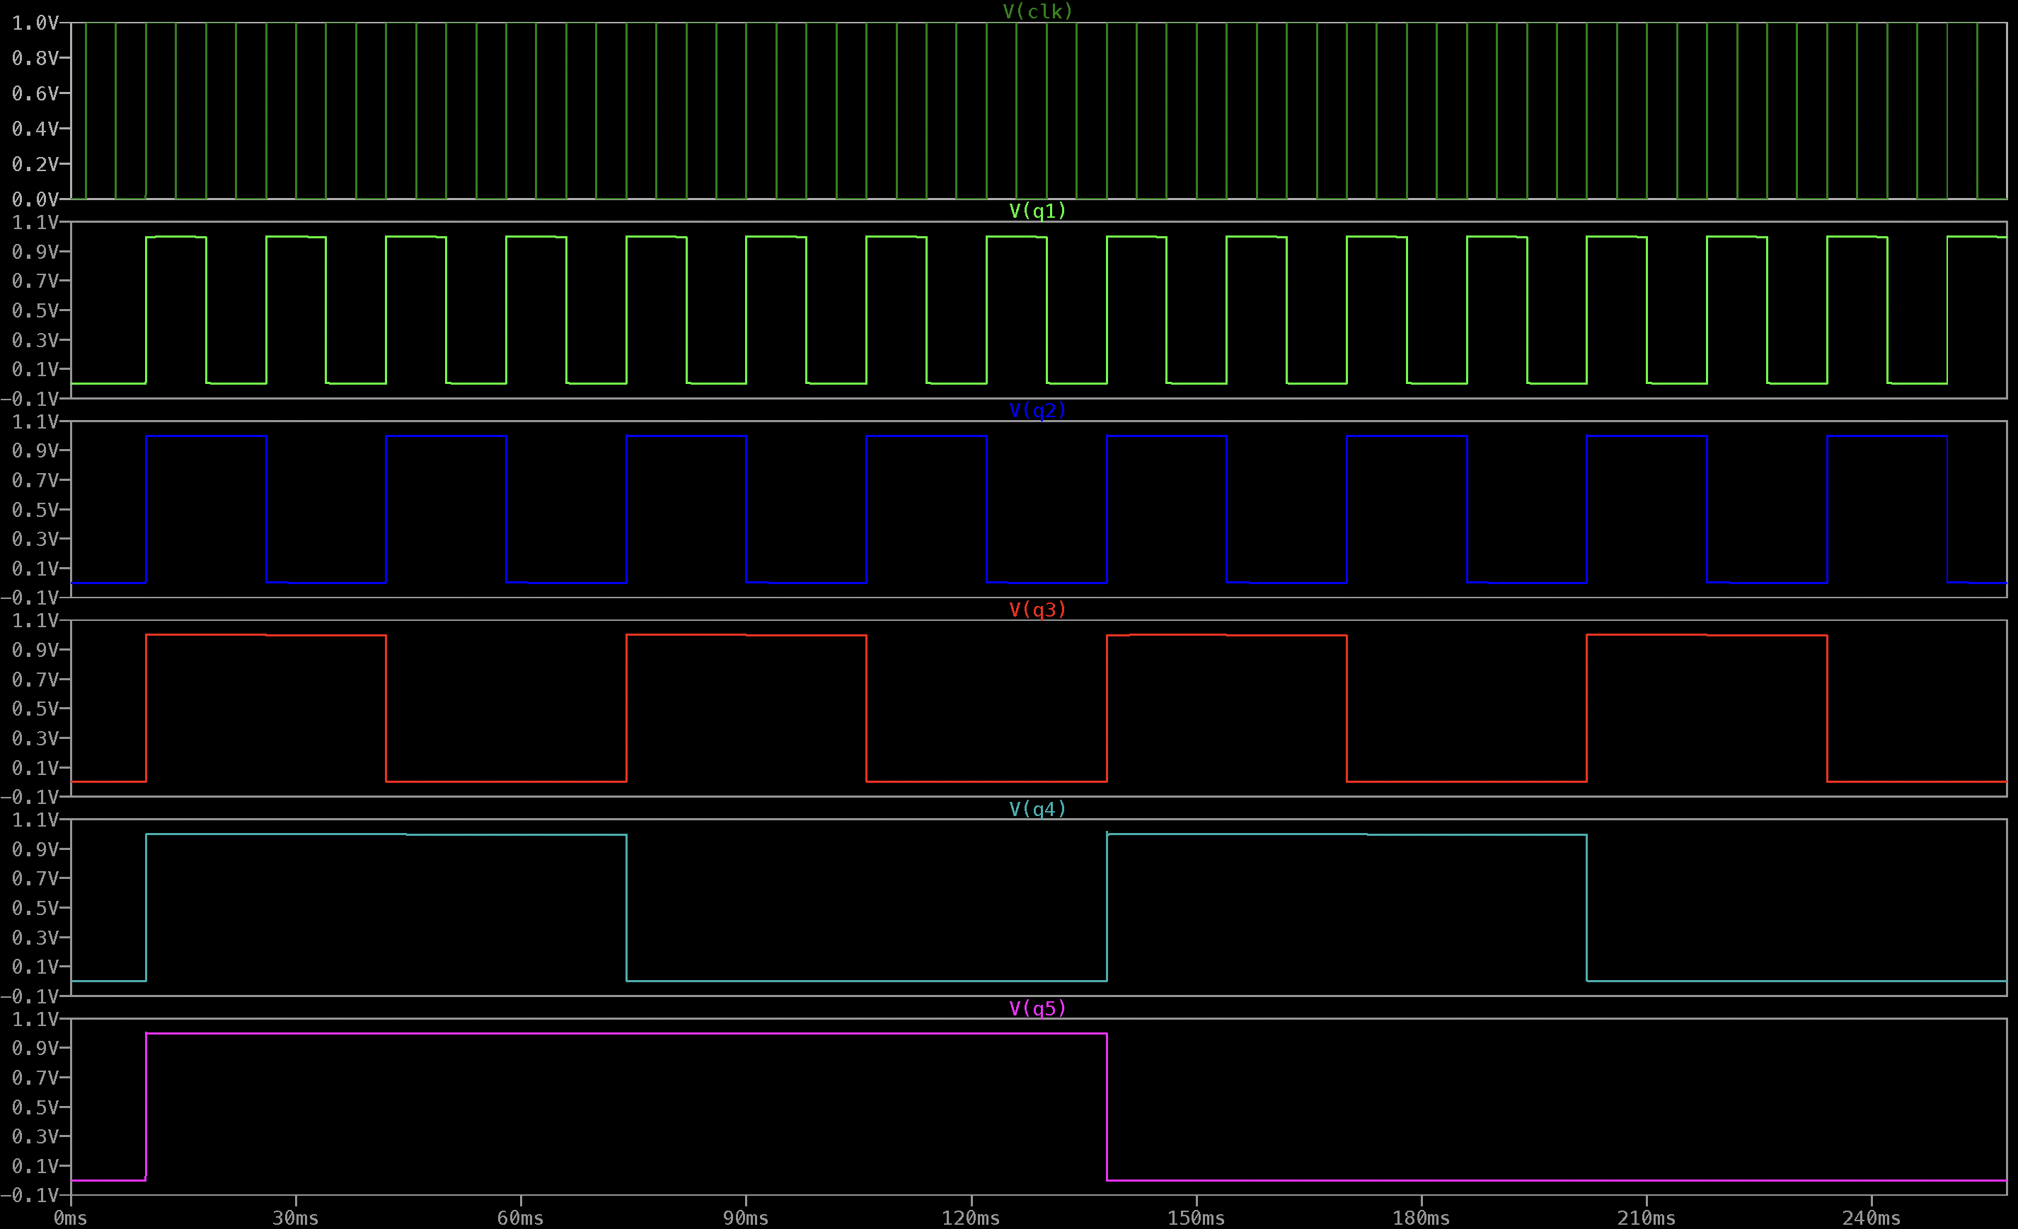
The DFlipFlop then doesn’t get the preset value.
This might make sense, as I am delayed my clock for 2ms, and then enabling at 2ms, meaning that the dflipflop never receives the preset value. The delay on the clock was to compensate for my hard reset. Let me test if it functions without the 2ms delay. In theory, the dflipflop should just be stuck at the same value for 2ms then.

Error found
When I make my flip flop stuck at at a value, the $Q_{x+1}$ flip flop won’t get a clock value, if what it receives is 0.
No matter what value I then feed it, it won’t ever change.

I see this could be found by keeping the hard reset on until after the enable signal has changed, making sure, that every one of the bits gets to have one pulse into its clock.
Or maybe by sending a pulse from the enabler into the clock.

I tried some things but didn’t really manage to fix this. But I won’t be using more time on this.

Final conclusions
From the founding of the divide by 2 method, I derived a method for counting up and down.
The dividing by 2 method was however the issue as two why I didn’t manage to get my load function to work, as I couldn’t load numbers, as some of the bits might never receive a clock signal.
I didn’t manage to find a solution to this.

For counting up, I set the clock signal for the $D_{x+1}$ to be the $\overline{Q_{x}}$as I derived, that a count up would equal the more significant bit inverting itself when the lesser significant bit were on the FALLING EDGE.

For counting down, the clock for the $D_{x+1}$ would be made out of the $Q_{x}$, as I derived, that a countdown would be equivalent to the lesser significant bit being on its RISING EDGE.
The results of the clock counting down:
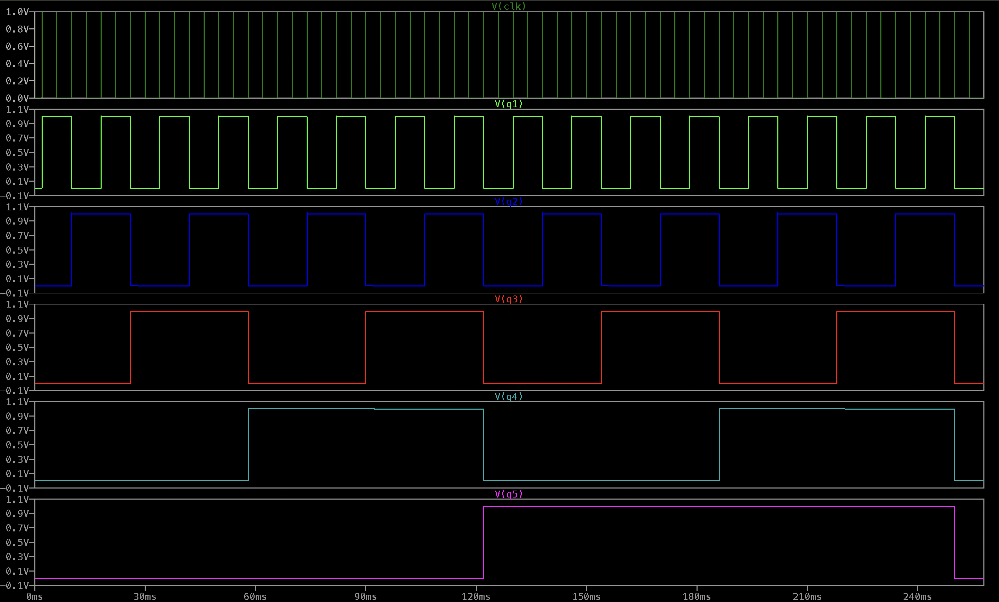

And voila it works like a charm counting up.
Changing the clock values of $D_{x+1}$ to be $Q_{x}$ results in:
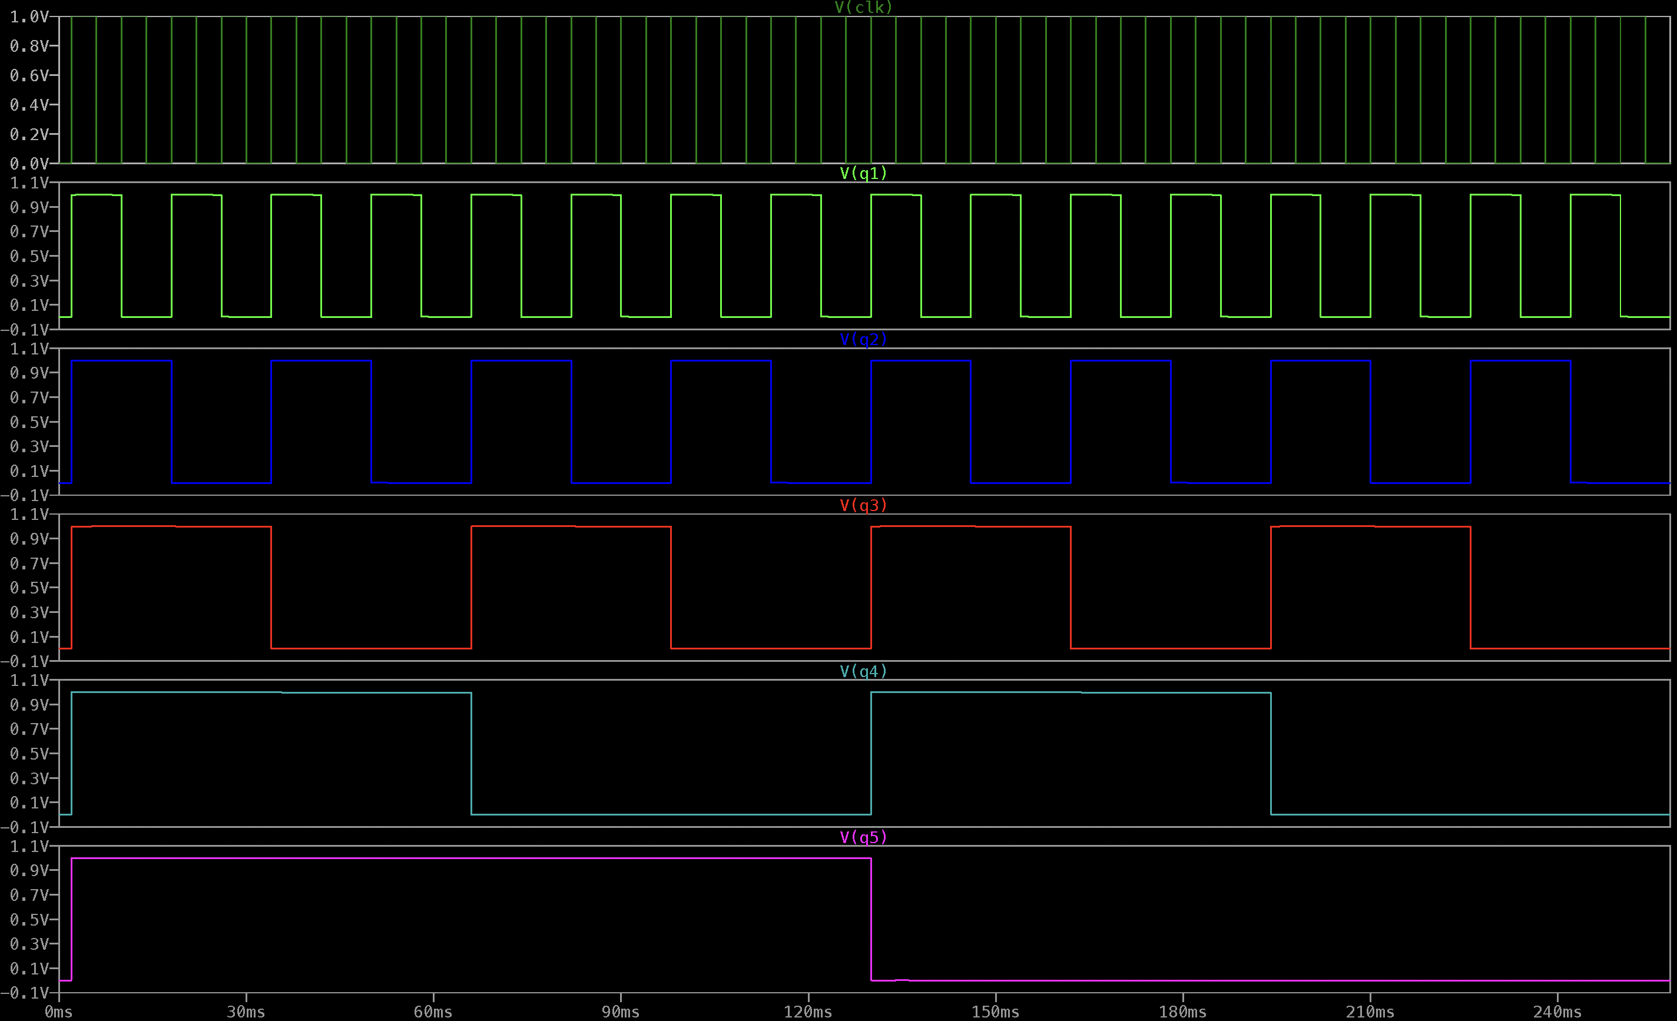
And so, my thesis of changing the edge trickers for the counter would change whether it counted up / down, has been shown to be true. That’s pretty awesome!

I managed to make a 5bit clock, being able count up and down easily. It’s able to reset itself. It has some flaws when the enable signal is 0, taking in the load values, and so having difficulties with the enable and load part. I made it found from the divide by 2 method, that I haven’t used before to make a counter, so I learned a lot, and is proud to have gotten it to somehow work.

